PRAKTIKUM BASIS DATA

MODUL 2
(DDL/DML, Data types, Authorization)



Oleh:

(Cikal Chrestella Cora) (103122400051)

PROGRAM STUDI S1 REKAYASA PERANGKAT LUNAK DIREKTORAT KAMPUS PURWOKERTO UNIVERSITAS TELKOM
2026

JURNAL/TP

- Soal 1
  - Table film Source code :
create table film ( id_film number primary key,judul varchar(100), sinopsis varchar(255), tahun number,durasi number);
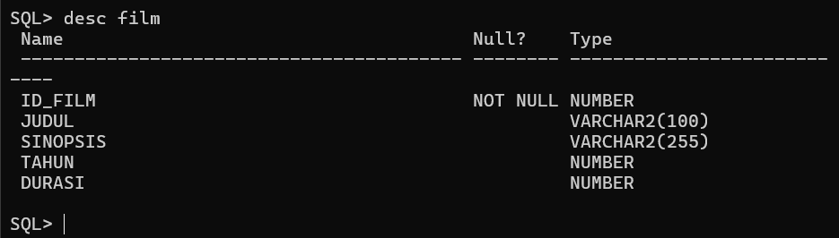

  - Table theater Source code :
create table theater (id_theater number primary key, harga number, kapasitas number,kelas varchar(50));
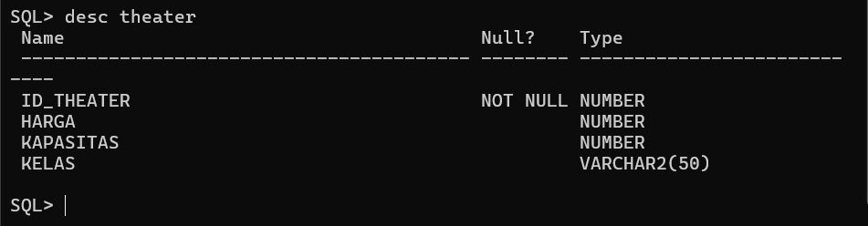

  - Table member Source code :
create table member (id_member number primary key,nama varchar(100), no_hp number, tgl_lahir date,email varchar(100));
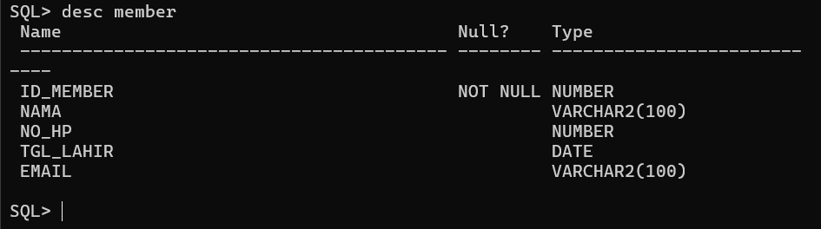
  - Table jadwal Source code :
create table jadwal (id_jadwal number primary key,id_film number, id_theater number,periode_start date,periode_end date,
constraint fk_film foreign key (id_film)references film(id_film), constraint fk_theater foreign key (id_theater)references theater(id_theater));
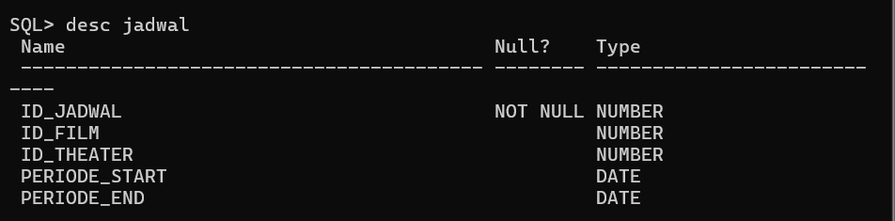

  - Table inventaris Source code :
create table inventaris ( id_inventaris number primary key,id_theater number, nomor_kursi number,constraint fk_theater_invforeign key (id_theater)references theater(id_theater));
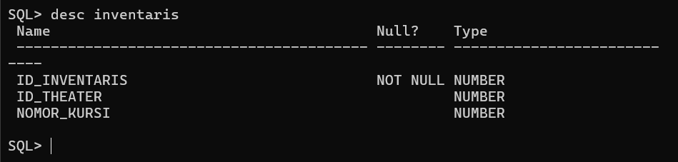

  - Table transaksi Source code :
create table transaksi (kode_pemesanan number primary key,id_jadwal number,id_member number,status varchar(50),tanggal date,total_harga number,constraint fk_jadwalforeign key (id_jadwal)references jadwal(id_jadwal),constraint fk_memberforeign key (id_member) references member(id_member));
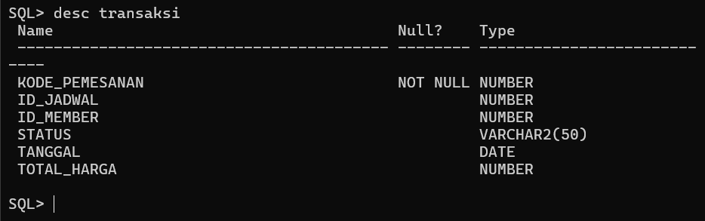

- Soal 2
  - Insert film

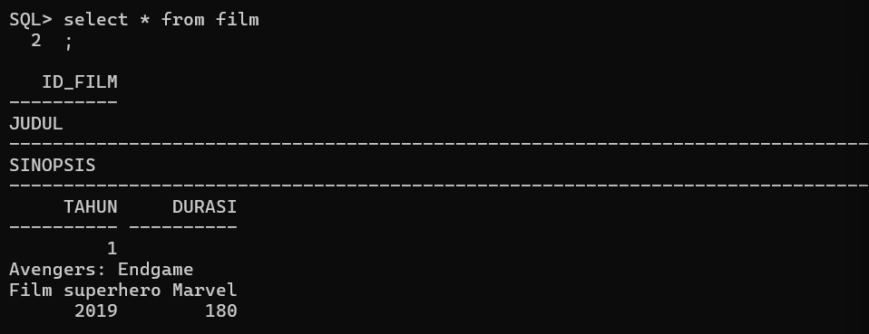
insert into film (id_film, judul, sinopsis, tahun, durasi)
values (1, 'Avengers: Endgame', 'Film superhero Marvel', 2019, 180);
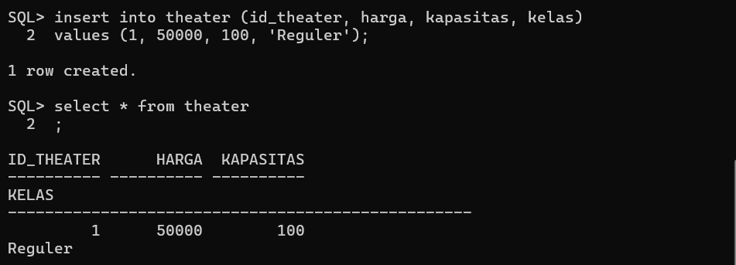
  - Insert theater

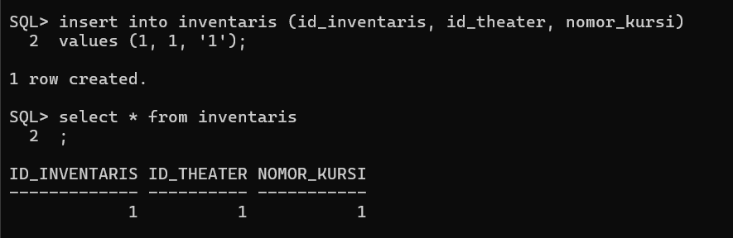
  - Insert inventaris

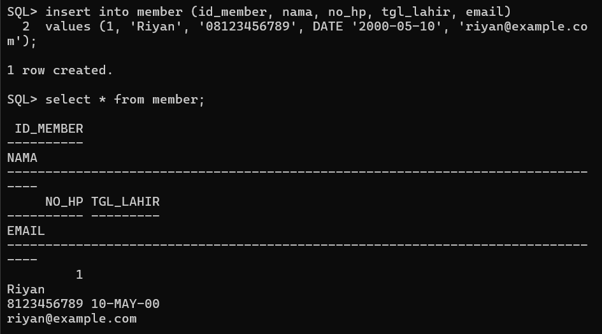
  - Insert member

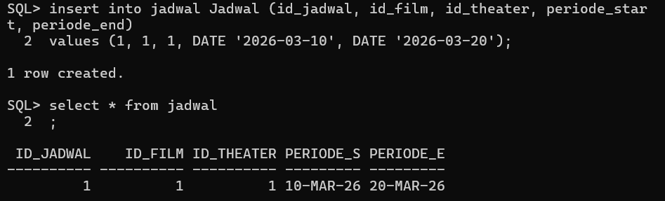
  - Insert jadwal

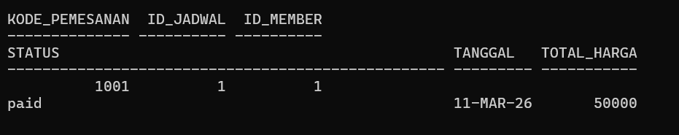
  - Insert transaksi

- Update data
  - Update judul film dan durasi

Source code : UPDATE film
SET judul = 'doraemon' WHERE id_film = 1; UPDATE film
SET durasi = 100 WHERE id_film = ;
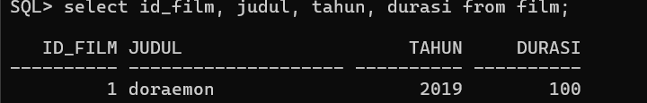

  - Update harga theater Source code :
update theater set harga = 1000
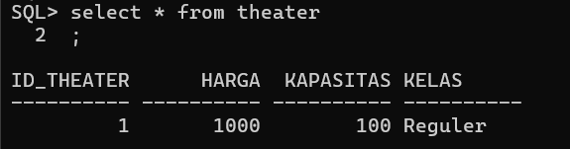
where id_theater = 1;

  - Update no hp member Source code :
update member
set no_hp = 01010101 where id_member = 1;
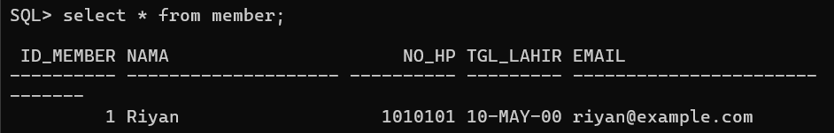

  - Update status menjadi lunas Soure code :

update transaksi set status = 'lunas'
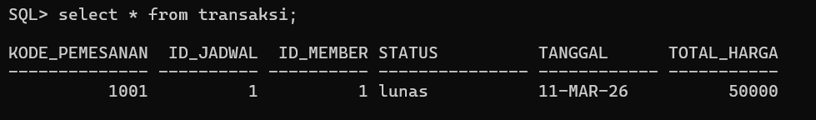
where kode_pemesanan = 1001;

- Delete
  - Row 1 transaksi Delete from transaksi
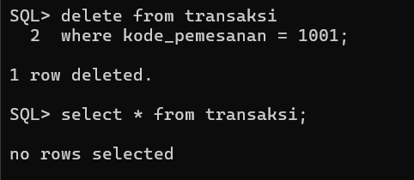
Where kode_pemesan = 1001;

  - Row 1 member delete from member
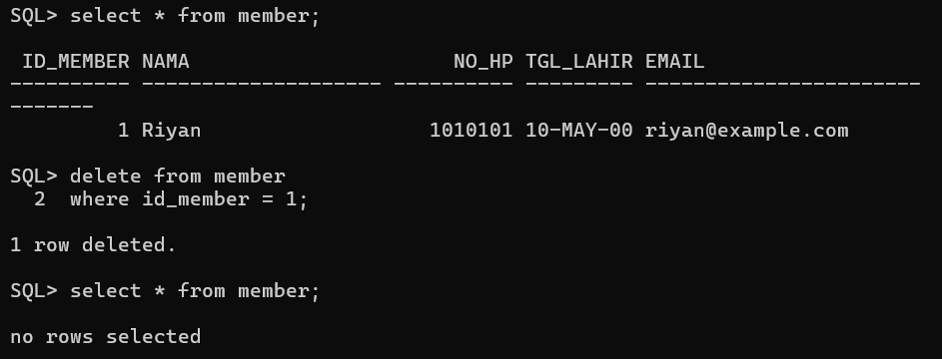
where id_member = 1;

